
American International University- Bangladesh
Faculty of Science and Technology

Acoustic Signatures of Parkinson’s Disease:
Leveraging Voice Data for Predictive Insights

Ismam Sadat Alam Taseen (21-45942-3)
Shahadat Hossain Sakib (21-45983-3)
Alif Hassan (21-45940-3)
Shuvo Chandra Mali (21-45971-3)

Supervised By
Prof. Dr. Afroza Nahar

A Thesis submitted for the degree of Bachelor of Science (BSc) in
Computer Science and Engineering (CSE) at
American International University- Bangladesh
Faculty of Science and Technology (FST)

Summer 2024 -2025
4th December 2025
Declaration
This thesis is composed of our original work, and contains no material previously published or written by another person except where due reference has been made in the text. We have clearly stated the contribution of others to our thesis, including statistical assistance, survey design, data analysis, significant technical procedures, professional editorial advice, financial and any other original research work used or reported in our thesis. The content of our thesis is the result of work we have carried out since the commencement of the Thesis.
We acknowledge that copyright of all material contained in my thesis resides with the copyright holder(s) of that material. Where appropriate, we have obtained copyright permission from the copyright holder to reproduce material in this thesis and have sought permission from co-authors for any jointly authored works included in the thesis.

_______________________________  Ismam Sadat Alam Taseen  21-45942-3  CSE | _______________________________  Shahadat Hossain Sakib  21-45983-3  CSE
_______________________________  Alif Hassan  21-45940-3  CSE | _______________________________  Shuvo Chandra Mali  21-45971-3  CSE

Approval
The thesis titled “Acoustic Signatures of Parkinson’s Disease: Leveraging Voice Data for Predictive Insights” has been submitted to the following respected members of the board of examiners of the department of computer science in partial fulfillment of the requirements for the degree of Bachelor of Science in Computer Science & Engineering on 4th December 2025 and has been accepted as satisfactory.

DR. AFROZA NAHAR  Professor & Supervisor  Department of Computer Science  American International University-Bangladesh |  |  | ANIK KUMAR SAHA  Lecturer & External  Department of Computer Science  American International University-Bangladesh
DR. MUHAMMAD FIROZ MRIDHA Professor & Head (UG)
Department of Computer Science
American International University-Bangladesh

DR. DIP NANDI  Professor & Associate Dean  Faculty of Science and Technology  American International University-Bangladesh |  |  | MASHIOUR RAHMAN  Sr. Associate Professor  Dean-In-Charge  Faculty of Science and Technology  American International University-Bangladesh

Acknowledgement
We would like to express our deepest appreciation to our esteemed supervisor, Dr. Afroza Nahar, Professor, Department of Computer Science, American International University-Bangladesh, for her invaluable guidance, constructive feedback, and unwavering support throughout every stage of this research. Her scholarly insight and academic leadership have been instrumental in shaping the direction and quality of our work.
We are also sincerely grateful to Anik Kumar Saha, Lecturer & External Examiner, for his critical evaluation and thoughtful recommendations, which significantly contributed to the enhancement of this thesis.
Our thanks also extend to Dr. Muhammad Firoz Mridha, Professor and Head (UG), Prof. Dr. Dip Nandi, Professor and Associate Dean, and Mashiour Rahman, Senior Associate Professor and Dean (in charge), Faculty of Science and Technology, for their valuable contributions and encouragement throughout the course of our undergraduate studies and thesis evaluation.
We are thankful to the faculty members and staff of the Department of Computer Science at AIUB for providing a supportive academic environment and necessary resources for the completion of our work.
We would also like to formally acknowledge the dedication and collaborative efforts of our thesis group members: The successful completion of this thesis is a direct result of our shared commitment, intellectual collaboration, and professional cooperation throughout all phases of the project.
Finally, we extend our heartfelt appreciation to our families and wishers for their continuous encouragement, patience, and moral support, without which this endeavor would not have been possible.

Author Contributions
 | Ismam Sadat Alam Taseen | Shahadat Hossain Sakib | Alif Hassan | Shuvo Chandra Mali | Comments
 | 21-45942-3 | 21-45983-3 | 21-45940-3 | 21-45971-3
0, 3 points | Perform as effective individual
Critical thinking | 3 | 3 | 3 | 3
Reflection on feedback | 3 | 3 | 3 | 3
Quality of work | 3 | 3 | 3 | 3
Self-directed | 3 | 3 | 3 | 3
0, 3 points | Perform as effective team member/leader
Taking responsibility | 3 | 3 | 3 | 3
Contribution | 3 | 3 | 3 | 3
Collaboration | 3 | 3 | 3 | 3
Working with others | 3 | 3 | 3 | 3
0, 3 points | Perform as effective team member/leader
Presentation delivery | 3 | 3 | 3 | 3
Voice and tone | 3 | 3 | 3 | 3
Enthusiasm | 3 | 3 | 3 | 3
Creativity & Tools use | 3 | 3 | 3 | 3

Project-Thesis Planning

Table 0.1: Project-Thesis Deliverables
Project Tasks | Schedule Data | Execution Data
- Planning | 2025.07.08 - 2025.07.25 | 2025.07.25
- Literature Review | 2025.07.25 - 2025.10.18 | 2025.10.18
- Selecting Efficient Model | 2025.10.18 - 2025.11.05 | 2025.11.05
- Testing Different Models | 2025.11.05 - 2025.11.20 | 2025.11.20
- Writing Thesis Report | 2025.11.20 - 2025.11.30 | 2025.11.30
- Submission and Review | 2025.11.30 - 2025.12.04 | 2025.12.04

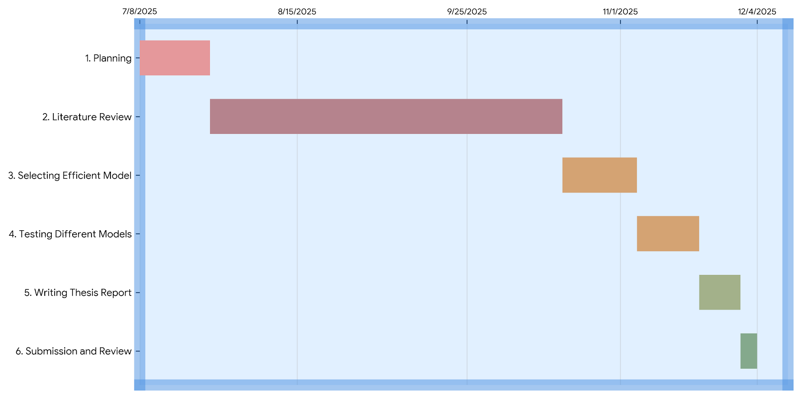
Figure 0.1 Project-Thesis Planning.

Table of Contents
APPROVAL iii
ACKNOWLEDGEMENT iv
AUTHOR CONTRIBUTIONS v
PROJECT-THESIS PLANNING vi
TABLE OF CONTENTS vii
LIST OF FIGURES x
LIST OF TABLES xi
LIST OF ABBREVIATIONS xii
ABSTRACT xiii
KEYWORDS xiii
CHAPTER 1 1
INTRODUCTION 1
1.1 BACKGROUND 1
1.2 RESEARCH MOTIVATION 3
1.3 PROBLEM STATEMENT 4
1.4 RESEARCH QUESTIONS 4
1.5 RESEARCH OBJECTIVES 5
1.6 RESEARCH CONTRIBUTIONS 7
1.7 THESIS STRUCTURE 8
CHAPTER 2 9
LITERATURE REVIEW 9
2.1 INTRODUCTION 9
2.2 LITERATURE REVIEW 9
2.3 SUMMARY 13
CHAPTER 3 14
METHODOLOGY 14
3.1 CONCEPTUAL FRAMEWORK 14
3.2 DATA COLLECTION 16
3.2.1 DATASET DESCRIPTION 16
3.2.2 DATASET PREPARATION AND NORMALIZATION 17
3.2.3 DATASET SPLITTING 20
3.3 FEATURE ENGINEERING 21
3.4 MULTIMODAL MODEL ARCHITECTURE 22
3.4.1 BASE MODEL LAYER 22
3.4.2 ENSEMBLE MODEL LAYER 23
3.5 TRAINING PROTOCOL 23
3.6 EVALUATION METRICS 24
3.7 CROSS-VALIDATION STRATEGY 25
3.8 DIAGNOSTIC VISUALIZATIONS AND INTERPRETABILITY 26
3.9 PROFESSIONAL ETHICAL ISSUES 26
3.10 ECONOMIC DECISION 27
3.11 METHODOLOGICAL SUMMARY 28
CHAPTER 4 29
RESULTS ANALYSIS 29
4.1 EXPERIMENTAL SETUP 29
4.2 MODEL DEVELOPMENT 30
4.3 EXPLORATORY DATA ANALYSIS (EDA) 30
4.3.1 HISTOGRAM ANALYSIS 32
4.3.2 INSIGHTS FROM THE DISTRIBUTION 32
4.4 CORRELATION AND FEATURE RELATIONSHIP ANALYSIS 33
4.4.1 FEATURE IMPORTANCE 33
4.5 MODEL PERFORMANCE EVALUATION 35
4.6 MODEL ACCURACY COMPARISON 37
4.7 SUMMARY OF EXPERIMENTAL RESULTS 38
CHAPTER 5 39
DISCUSSION 39
5.1 INTERPRETATION OF FINDINGS 39
5.1.1 SUPERIOR PERFORMANCE OF ENSEMBLE MODELS 40
5.1.2 SIGNIFICANCE OF VOCAL 42
5.2 COMPARISON WITH EXISTING LITERATURE 42
5.2.1 IMPROVED ACCURACY OVER TRADITIONAL MODELS 42
5.2.2 ENHANCED INTERPRETABILITY 43
5.2.3 HANDLING DATASET IMBALANCE 43
5.2.4 PRACTICAL AND LIGHTWEIGHT MODELS 43
5.3 CLINICAL AND PRACTICAL IMPLICATIONS 43
5.3.1 NON-INVASIVE AND ACCESSIBLE SCREENING 43
5.3.2 REDUCING MISDIAGNOSIS 43
5.3.3 SUPPORT FOR CLINICIANS 44
5.4 ETHICAL, PROFESSIONAL, AND ECONOMIC CONSIDERATIONS 44
5.5 LIMITATIONS OF THE STUDY 44
CHAPTER 6 45
CONCLUSION AND FUTURE WORK 45
6.1 CONCLUSION 45
6.2 FUTURE WORK 46
REFERENCES 47

List of Figures

Figure 0.1: | Project-Thesis Planning | Vi
Figure 3.1: | Parkinson's Disease Prediction System | 15
Figure 3.2: | Data Processing and Modeling Workflow | 18
Figure 3.3: | Feature Importance Ranking from Random Forest | 22
Figure 3.4: | Visual Representation of the Confusion Matrix | 25
Figure 4.1: | Histogram Representation of Feature Distributions | 31
Figure 4.2: | Correlation Heatmap of Dataset Features | 34
Figure 4.3: | Acoustic Feature Importance for Parkinson’s Detection Model | 36
Figure 4.4: | Model Accuracy Comparison | 38

List of Tables

Table 0.1:  Table 1.1:  Table 3.1:  Table 4.1: | Project-Thesis Deliverables  Alignment of Research Objectives and Research Questions  Summary of Key Dataset Features  Model Performance Comparison | vi  06  17  36

List of Abbreviations
PD | Parkinson’s Disease
WHO | World Health Organization
ML | Machine Learning
AI | Artificial Intelligence
RFE | Recursive Feature Elimination
RF | Random Forest
DT | Decision Tree
SVC | Support Vector Classifier
XGBoost | Extreme Gradient Boosting
LGBM | Light Gradient Boosting Machine
KNN | K-Nearest Neighbors
LR | Logistic Regression
MLP | Multi-Layer Perceptron
AB  AUC  F1 | AdaBoost  Area Under Curve  F1 Score
TP | True Positive
TN | True Negative
FP | False Positive
FN | False Negative

Abstract

Early and accurate detection of Parkinson’s disease (PD) remains a critical challenge in clinical neurology, as conventional diagnostic methods are often time-consuming, subjective, and costly. This study suggests a machine learning-based framework for the noninvasive prediction of PD using voice-based biomarkers. A total of twelve classification models were developed and evaluated, including simple algorithms such as logistic regression and support vector machines to more advanced ensemble approaches, including random forest and gradient boosting. These models were then combined into a soft voting ensemble to improve the accuracy of the predictions. Each model was trained separately on the identical preprocessed dataset acquired from a public repository featuring 195 voice recordings, maintaining uniformity, and an equitable and fair comparison. The preprocessing pipeline included scaling the features, dividing the data into sets, and managing class imbalance using a RandomOverSampler. The model's performance was evaluated using accuracy, precision, recall, and F1-score obtained from the confusion matrix on a test set that had never been studied before. With an accuracy of 98.88% and precision and recall values of 98.90%, the soft voting ensemble which merged the top three performing classifiers performed the best out of all the strategies and approaches that were employed. This study addressed practical issues by promoting equity through balanced class distributions and improving interpretability through feature importance analysis in addition to predicting accuracy. A good substitute for traditional diagnostic techniques is both economical and computationally efficient, which is suggested by this study. The results show that ensemble learning significantly improves diagnostic reliability, suggesting a cost-effective and computationally efficient alternative to traditional PD screening methods. This work highlights the potential of integrated machine learning approaches for advancing voice-based neurological diagnostics.

Keywords
Parkinson's disease, Machine Learning, Voice Features, Ensemble Learning, Voting Classifier, Non-invasive Diagnosis, Telemedicine.

CHAPTER 1

INTRODUCTION

Background
Parkinson’s disease (PD) is a progressive neurodegenerative disorder caused by the loss of dopamine-producing neurons in the mid brain, which causes 50–80% reduction in dopamine levels. This deficiency of dopamine defects motor function, causing involuntary actions like tremors, rigidity, and slow movements. These motor symptoms start softly and increase gradually making the early diagnosis difficult.
In addition to motor symptoms, non-motor impairments such as speech disorders are also observed. PD causes the pitch of the voice to change, which is known as dysprosody [1]. Approximately 90% of individuals with PD experience vocal changes, including reduced loudness, monotonic speech, and imprecise articulation that make speech and voice unclear due to incorrect movement of the tongue. This is one of the early stages of the disease [2]. This disturbance in voice or vocal alterations may occur months or even years before obvious motor signs, making this of the earliest symptoms of PD.
Diagnostics that were done before mainly focused on clinical evaluations, neurological examinations, and imaging techniques, which are costly, time-consuming, and were not correctly diagnosed. Furthermore, depending on the patients self-reports can make complicated diagnosis which will not be accurate but subjective bias. Previous studies predicting Parkinson’s disease (PD) have primarily focused on MRI scans, gait analysis, and genetic data, which can be very expensive or not suitable in village areas, with limited research on using audio impairment for early detection [3].
Traditional diagnosis methods are very hard to access or use because they are very expensive and is not affordable in many villages, because of which affordable voice-based machine learning can be helpful in areas with limited resources. Many studies report that nearly 24% of Parkinson’s disease (PD) cases are misdiagnosed during early stages [4]. It does not only slow the neuroprotective treatments but may harm the patients with wrong treatments. There is a great clinical need for trustworthy, simple, and readily available diagnostic techniques since early neuroprotective therapies greatly enhance patient outcomes. Accessible simple and cheap diagnostic tools could make positive changes to public healthcare strategies, allowing massive tests and timely interventions.
As dysfunctionality of voice features is one of the early stages of PD, analysis of it can be used as an effective alternative. Supporting phonation tasks and running speech exams can capture acoustic vocal features such as jitter, shimmer, harmonics-to-noise ratio (HNR), and formant frequencies, which are known biomarkers of PD-related dysphonia. The access to these vocal markers is relatively easy, as it can be extracted remotely using everyday devices such as smartphones, enabling large-scale and low-cost screening. This method suits well with the telemedicine and healthcare sectors, allowing early detection even for people living in remote or areas. Studies have demonstrated that vocal biomarkers taken from speech recordings can be used to distinguish Parkinson's disease (PD) using machine learning techniques [5]. It also helps doctors to monitor and check the patient’s voice data by studying changes in the vocal makers over time.
Early detection of Parkinson's disease (PD) which is a serious neurological condition has been made possible using machine learning (ML) in healthcare. Machine learning models can manage complex and large amounts of data, spotting patterns, and predict accurately that might be hard for humans to see using traditional statistical methods. In the last few years, voice and acoustic data have risen to be a powerful non-invasive biomarker. With parameters or inputs like jitter, shimmer, harmonic to noise ratio, and other non-linear dynamical parameters for classification in the context of PD, several researchers have been focusing on employing machine learning algorithms to analyze acoustic signals. Jitter, shimmer, harmonicons ratio (HNR), can be analyzed using supervised ML algorithms including Support Vector Machines (SVM), kNearest Neighbors (KNN), Decision Trees, and Random Forests. A study presented on PD identification with speech features indicates more than 90% when using ML models, SVM and ensemble classifiers developed on vocal recording data [6]. In our paper we used 12ML models including ensemble methods.-to-noise ratio (HNR), can be analyzed using supervised ML algorithms including Support Vector Machines (SVM), k-Nearest Neighbors (KNN), Decision Trees, and Ra
Moreover, integrating modern approaches like voice recognition technology and machine learning with traditional approaches may help increase and support confidence and conviction for diagnostic and patient outcomes, while lowering rates of misdiagnosis. This research shows that model performance and accuracy rely mainly on proper data preprocessing, feature scaling, and class balancing, thus underscoring the need for methodological discipline around medical ML. Taken together, the three attributes further contribute to the growing evidence that voice-based biomarkers have the potential to change the face of early detection in PD. The study finally highlights new frontiers of AI and the democratization of healthcare to lower resource countries by making advanced and accurate diagnostic tools available to them.

Research Motivation
Parkinson’s disease (PD) is a progressive neurological disorder that significantly affects motor functions and is often accompanied by non-motor symptoms such as sleep disturbances, mood disorders, and cognitive decline. Among its early manifestations, voice impairments—such as reduced pitch variability and speech irregularities offer a promising, non-invasive biomarker for early detection. However, these vocal symptoms are frequently overlooked in conventional diagnostic practices despite their potential clinical significance.

Recent advances suggest that voice-based features contain discriminative patterns capable of identifying PD at early stages. The integration of machine learning (ML) techniques with such vocal biomarkers provides a scalable, cost-effective, and non-invasive alternative to traditional diagnostic approaches. This motivates the development of robust ML frameworks that can leverage voice data for accurate and early PD detection.

Problem Statement

Despite promising progress, several critical limitations remain in existing ML-based PD detection studies:
- Lack of comprehensive model comparison: Many studies rely on a single classifier or a limited set of models without conducting systematic comparisons under consistent preprocessing and evaluation conditions. This limits the reliability and generalizability of the findings.
- Insufficient focus on interpretability: The interpretability of ML models is often overlooked, reducing clinical trust and limiting understanding of which vocal features are most indicative of Parkinson’s disease.
- Underutilization of ensemble techniques: Ensemble learning methods, which can leverage the complementary strengths of multiple classifiers, are not widely explored. This results in missed opportunities to improve diagnostic accuracy and robustness.

To address these gaps, there is a need for a unified framework that integrates multiple classifiers, ensures fair evaluation, incorporates interpretability, and leverages ensemble learning to enhance the accuracy and reliability of voice-based Parkinson’s disease detection.

Research Questions
This thesis is guided by the following research questions:
- RQ1: How do different machine learning techniques such as Decision Tree, Random Forest, Gradient Boosting, Extra Trees, and ensemble methods, compare in terms of predictive accuracy, precision, recall, and F1-score for Parkinson’s disease detection using vocal features?
- RQ2: What extent does feature selection based on Random Forest importance improve and enhance model interpretability and classification performance compared to training on the full feature set?
- RQ3: How effective are ensemble strategies, such as Voting Classifiers combining top-performing models, in enhancing robustness and generalization compared to individual classifiers?
- RQ4: What trade-offs exist between predictive accuracy, interpretability, and computational feasibility (in terms of runtime and resource usage) when deploying lightweight ML models for real-world telemedicine applications in Parkinson’s disease detection?

The study aims to create a systematic standard for voice-based Parkinson's detection models through its research work which will advance telemedicine and remote healthcare systems as well as machine learning research in medical diagnosis.

Research Objectives
The objectives of this paper are as follows:
  - To develop a robust preprocessing pipeline for the Parkinson’s disease dataset, including feature scaling and class balancing using RandomOverSampler, to ensure unbiased model training and evaluation.
  - To analyze and identify the most significant vocal biomarkers using feature importance techniques based on Random Forest, highlighting key features such as PPE, spread1, Shimmer:APQ5, and MDVP:APQ.
  - To implement and evaluate a diverse set of machine learning models, including Logistic Regression, Decision Tree, Random Forest, Gradient Boosting, Support Vector Machine (SVM), K-Nearest Neighbors (KNN), Naïve Bayes, AdaBoost, Bagging, and Extra Trees classifiers.
  - To compare model performance using standard evaluation metrics, including accuracy, precision, recall, and F1-score, in order to identify the most effective classifiers.
  - To design and develop ensemble learning strategies, including Voting and Stacking classifiers, by integrating top-performing models to enhance predictive performance.
  - To conduct comprehensive performance evaluation using confusion matrices, classification reports, and comparative analysis to ensure transparency and interpretability.
  - To propose a lightweight, cost-effective, and clinically applicable machine learning framework for early Parkinson’s disease detection, suitable for deployment in telemedicine and resource-constrained environments.
This paper does not only focus on using multiple ML algorithms for PD detection but also provides useful insights into the most important speech features and the practical feasibility of ensemble-based diagnostic models.

Table 1.1: Alignment of Research Objectives and Research Questions
Research Questions (RQ) | Research Objectives (RO)
RQ1: How do different machine learning algorithms compare in terms of predictive performance (accuracy, precision, recall, and F1-score) for Parkinson’s disease detection using vocal features? | RO1: To implement and evaluate a diverse set of machine learning models, including Logistic Regression, Decision Tree, Random Forest, Gradient Boosting, SVM, KNN, Naïve Bayes, AdaBoost, Bagging, and Extra Trees classifiers.
RQ2: To what extent does feature selection based on Random Forest importance improve model interpretability and classification performance compared to using the full feature set? | RO2: To analyze and rank vocal features using Random Forest-based feature importance and identify key biomarkers (e.g., PPE, spread1, Shimmer: APQ5, MDVP:APQ) contributing to PD classification.
RQ3: How effective are ensemble learning strategies in improving robustness and predictive performance compared to individual classifiers? | RO3: To design and develop ensemble models, including Voting and Stacking classifiers, by integrating top-performing individual models.
RQ4: What is the impact of data preprocessing and class balancing on model fairness and generalization performance? | RO4: To develop a preprocessing pipeline incorporating feature scaling and class balancing using RandomOverSampler to ensure unbiased training and evaluation.
RQ5: What trade-offs exist between predictive accuracy, interpretability, and computational efficiency for lightweight ML models in telemedicine applications? | RO5: To evaluate model performance in terms of accuracy, interpretability, and computational cost (runtime and resource usage) to identify practical models for real-world deployment.
RQ6: How can model evaluation and visualization enhance transparency and clinical trust in PD prediction systems? | RO6: To perform comprehensive evaluation using confusion matrices, classification reports, and comparative analysis to ensure interpretability and transparency.

Research Contributions
The research study focusing on Parkinson Disease using a voice features framework is primarily useful for clinic practitioners, healthcare researchers, and telemedicine providers. These stakeholders often face numerous problems in observing accurate and reliable diagnosis, as delays or misclassifications can adversely impact treatment decisions and patient outcomes. By employing the developed machine learning models, the framework offers:

- Providing a unified benchmarking of multiple ML models under consistent preprocessing to better treatment and effective management of tactics for patients.
- Easy for any organization to implement, as lightweight models such as Decision Trees and Logistic Regression enable for usage in low-resource or real-time telemedicine settings.
- Proposing an ensemble-based framework for improved PD detection using voice biomarkers.

It uses twelve machine learning algorithms, including Decision Trees, Random Forests, Gradient Boosting, and ensemble methods which are trained under preprocessed and normalized data for fair and better accuracy, making it a comprehensive benchmark. For identifying the most important vocal features, this study demonstrates and uses Random Forest feature importance, which therefore improves both performance and interpretability. Furthermore, the study focuses on Voting Classifier ensemble combining top-performing models to increase the robustness and accuracy; this tells us about the effectiveness of ensemble strategies. Lastly, by combining interpretability tools with computational efficiency analysis, the thesis closes the gap between academic research and clinical application, facilitating the implementation of reliable, scalable, and lightweight models in actual telemedicine settings.

Thesis Structure
- Chapter 1: This opening section introduces the context of the study, exploring the connection of neurodegenerative health and voice analysis. It defines the core research motivation, identifies gaps in diagnostic practices, and presents the research questions, objectives, and unique contributions that drive this project.
- Chapter 2: This chapter provides a critical literature review of the recent scientific researches. Examining prior machine learning frameworks and the historical evolution of vocal biomarkers provides the theoretical grounding necessary for the proposed detection system.
- Chapter 3: Serving as the technical heart of the thesis, this chapter discusses the proposed methodology spanning from data collection to model architecture. It covers crucial preprocessing steps such as class balancing via RandomOverSampler and explains the development of the 12-model framework and the integrated soft-voting ensemble.
- Chapter 4: Here, the focus shifts to the experimental results and exploratory data analysis. Through a series of diagnostic visualizations and performance metrics, this section provides a transparent, side-by-side comparison of how various algorithms interpret acoustic Parkinson’s data
- Chapter 5: Moving beyond raw data, this chapter interprets the biological and clinical significance of the findings. It navigates the complex ethical, economic, and professional considerations that would influence the real-world deployment of voice-based screening tools in telemedicine environments.
- Chapter 6: The final chapter discusses the primary findings and contributions of the work. It reflects on the study's impact on accessible healthcare and identifies potential future research directions for further refining acoustic-based neurological screening.

CHAPTER 2

LITERATURE REVIEW

Introduction
Numerous research studies have demonstrated that vocal biomarkers taken from speech recordings can be used by machine learning algorithms to classify Parkinson's disease (PD). Govindu and Palwe demonstrated that vocal biomarkers taken from speech recordings can be used by machine learning algorithms to distinguish between healthy individuals and patients with Parkinson's disease (PD) [7]. Several researchers have tackled the challenge of classifying PD using various machine learning (ML) methods, using techniques like Recursive Feature Elimination and Feature Importance to find the most pertinent characteristics. Decision trees, support vector machines (SVMs), artificial neural networks, and other machine learning models have all undergone substantial testing. Among them, support vector machines produced the greatest outcomes, especially when combined with recursive feature elimination. A study was done using a UCI dataset comparing KNN, SVM, and Decision Tree, Random Forest, and MLP models using voice signal features. But they were unable to use feature selection, forcing researchers to include all features in the final model [8].

Literature Review
Senturk employed feature significance and Recursive Feature Elimination (RFE) strategies to identify the most relevant vocal features. Predictions were then made using classifiers such as Classification and Regression Trees (CART), Artificial Neural Networks (ANN), and Support Vector Machines (SVM) [9]. Among these, SVM with RFE yielded the highest accuracy of 93.84% with a minimum feature set, proving that feature selection can successfully lower dimensionality without compromising accuracy. In our research, we used the Random Forest Classifier to figure out our most important features because it does not remove any feature by itself like RFE. Additionally, we tested 12 models, including ensemble methods, and combined the best three models that have highest accuracy to obtain a combined accuracy of 98.88%.

Das evaluated several classifiers, including regression models, decision trees, and neural networks, with the purpose of detecting Parkinson's disease [10]. They also looked at different classifiers for finding Parkinson's disease, like Neural Networks, Decision Trees, and Regression Models. The study found that neural networks worked best, with an overall classification accuracy of 92.9%. In our paper, we used 12 different ML models including ensemble models, and also Das did not use feature selection, which may cause problems [10].

Most research on Parkinson’s disease (PD) detection focuses on using deep learning techniques. For instance, Gunduz uses ensemble deep learning models on voice data from UCI machine learning repository to predict the progression of Parkinson’s disease [11]. Their study did not include feature selection, which could have improved the performance of their deep learning model (CNN). Similarly Naanoue used a deep learning model approach with a 93% accuracy rate [12]. They used LSTM model to detect patients with PD. However, the high memory needs made it costly and also their dataset was imbalanced. Another study of Demir reached an accuracy of approximately 95.4% which combined L1-norm SVM and Chi-square based methods, followed by classification with KNN, SVM, and decision trees [13]. Based on our literary review, we developed a combined ML model to classify Parkinson’s disease (PD) using an audio dataset, aiming to support advancements in telemedicine-based PD detection.

Most studies have found accuracy to be one of the most reliable and important factors for detecting early Parkinson disease using speech data. But accuracy can sometimes fail to perform, usually when dealing with imbalanced datasets, as is often the case with medical diagnosis problems. It is unacceptable for a model to be highly accurate in a real-world clinical setting but to miss a significant number of real-world Parkinson's cases. Karabayır’s high accuracy using SVM and Random Forest classifiers calls into question the model's reliability in actual diagnosis; nevertheless, their lack of precision, recall, or confusion matrix data raises questions [14]. Similarly, deep learning models in other studies achieved a great accuracy of 90%, but they were not interpretable and lacked key performance indicators like AUC or false positive/negative rates [15], [16]. Our research overcame these limitations as we evaluated our models using multiple performance metrics, including confusion matrix, accuracy, precision, and recall. Precision ensures that the model will not incorrectly identify healthy individuals as PD patients, whereas recall points to the correct identification of real PD patients. The confusion matrix highlights special category errors, such as false positives or false negatives, which are crucial in medical diagnostics. Previous research, like Ali et al. proposed ensemble models without looking at these particular metrics or the impact of each classifier [17]. Our model provides a more visible, readable, and highly reliable method for PD identification by reporting and analyzing all important variables.

In addition to these studies, more recent work has been investigating the use of hybrid feature engineering techniques to increase the accuracy of Parkinson’s disease detection. For instance, Rahmatallah blended the hand-crafted acoustic traits like jitter, shimmer, and the harmonics-to-noise ratio with deep-learned embedding’s derived from convolutional neural networks [18]. Their hybrid technique algorithmically and intelligently dominated the traditional single feature pipelines reaching an accuracy of 95.2% on the benchmark PC-GITA dataset. Also, Deng et al. proposed a two-stage feature selection technique whereby the first stage is a genetic algorithm-based optimization of a tiered mutual information filter optimizing the dimension of information while preserving predictive power [19]. Their study achieved a 0.93 F1 score by using an ensemble of the gradient boosting and random forest classifiers. These findings illustrate the effectiveness of integrating traditional and contemporary feature selection methods in enhancing the robustness of a classifier, providing further rationale for our decision to implement both single model evaluations and ensemble strategies.

Various other analysts emphasized the clinical applicability and generalizability of machine-learning models for the detection of Parkinson’s, especially from the viewpoint of actual telemedicine. For example, taking mobile deployment in particular, developed a mobile-assisted voice-condition-analysis system that retains practical feasibility alongside computational efficiency in real-world conditions [20]. Furthermore, investigations into language diversity have shown the importance of cross-linguistic generalization: Favaro et al. evaluated interpretable voice biomarkers across multiple languages (American English, Italian, Castilian Spanish, Colombian Spanish, German, and Czech) and found evidence that acoustic speech features may show language-independent behavior in the context of Parkinson’s disease detection [21].

Based on this, however, the work must do something beyond accurate, general, computationally efficient, and clinically viable models for the early screening of Parkinson’s disease. For detecting Parkinson disease using voice recognition, majority studies have already used weighted or stacking ensembles, contain additional models without a clear selection reason, or are unclear about the selection process for the best-performing models. In our research, we address this gap by first evaluating a wide range of twelve traditional machine learning models, including both base and ensemble classifiers. Among them, Bagging, Voting Ensemble, and Stacking Ensemble stood out with the highest individual accuracies of 98.88%, 98.88%, and 98.88%, respectively. To combine the strengths of these top-performing models, we developed a Voting Classifier ensemble, which achieved an accuracy of 98.88%, with precision and recall also at 98.90% and 98.88%, respectively. This makes it both very affordable and reliable by getting help from the best 3 models. In addition, the confusion matrix and classification report also ensured that our output is stable, as our model correctly classified 98% of Parkinson's cases and 97% control subjects. Such consistency in precision, recall, and F1-score ensures that the model generalizes well to new instances and has few false negatives a key point in the early diagnosis of PD. In addition, the ensemble's light computational framework facilitates online prediction perfect for clinical or mobile deployment settings.

Most of the research done previously uses either traditional stacking or boosting procedures or incorporates a wide range of models without providing reasons for their selection, knowing and ignoring the fact that ensemble methods are mostly used in related research. For example, some papers uses models like SVM, Random Forest, and Gradient Boosting to make a voting classifier that does not consider to first check each model’s accuracy [22]. Others used deep learning models or stacking ensembles, which produced respectable accuracy but had no feature importance ranking, restricted transparency, and increased computational costs [23]. Our research uses the best 3 models out of our 12 on evaluations and combines them into a Voting Classifier, making the output more transparent, accurate, and low costly.

Summary
While previous studies focus on deep learning and imaging approaches to PD detection, this is a lightweight, interpretable approach employing traditional machine learning methods based on vocal data. Unlike studies that apply complex models without feature selection, in our contribution to determining the most important voice indicators, we apply Random Forest, facilitating model efficiency and interpretability. The main novelty of this paper is the identification and comparison of key voice-based features using multiple traditional ML models. Furthermore, 12 ML models, including ensemble methods, are applied, which hardly can be found in existing literature. The use of intrusively collectable voice data and non-invasive methods further renders this study a scalable method for the early diagnosis of PD for telemedicine, especially for remote or resource-limited settings. Also, this study uses a novel combination of the 3 best models (Bagging, Voting Ensemble, and Stacking Ensemble), achieving high precision and a classification accuracy of 99%.

CHAPTER 3

METHODOLOGY

This chapter explains the scientific and rigorous approach for developing a machine learning system to predict Parkinson's disease (PD) based on voice data. The workflow is always described as an end-to-end procedure, beginning with conceiving a data collecting technique and progressing to a common preprocessing frequency, deep features engineering, model training comparison, and the evaluation protocol during research with many comparisons. Each phase was meant to highlight scientific rigor, repeatability, and the creation of dependable and understandable diagnostic equipment. The main objective was to verify the idea that voice biomarkers are a reliable non-invasive sign of early Parkinson's disease identification.

3.1 Conceptual Framework
The theoretical framework for this study endeavor is based on the assumption that Parkinson's Disease's neurodegenerative consequences cause tiny but observable alterations in voice output. The conceptual framework suggests that by collecting and analyzing many or numerous acoustic variables from individuals' speech signals, machine learning models may be taught to discover complex characteristics/functions that distinguish healthy people from those with Parkinson's disease.

Figure 3.1 shows the system's architectural design, which follows the natural flow of collecting data to diagnostic output. The entire method begins with the collection of voice samples, from which the ideal acoustic characteristics will be determined. These features guide the input to the main processing pipeline, composed of three vital processes: preprocessing, balancing, and scaling, all of which prepare the data for modeling.

In the modeling process, a comparison method is used. Rather of using a single model, a number of machine learning models (Logistic Regression, Support Vector Machine (SVM), Random Forest, and K-Nearest Neighbors (KNN)) are trained sequentially. The best models' outputs are merged into a 'Soft Voting Ensemble' model. Soft Voting Ensemble combines multiple models to take advantage of the strengths of the models used in the voting ensemble, improving their combined accuracy and reliability versus using only one model for making the final prediction about Parkinson's status (0 healthy, 1 PD to assist clinicians). The overall structure of the framework helps to provide some more general context for the information that is being reported.

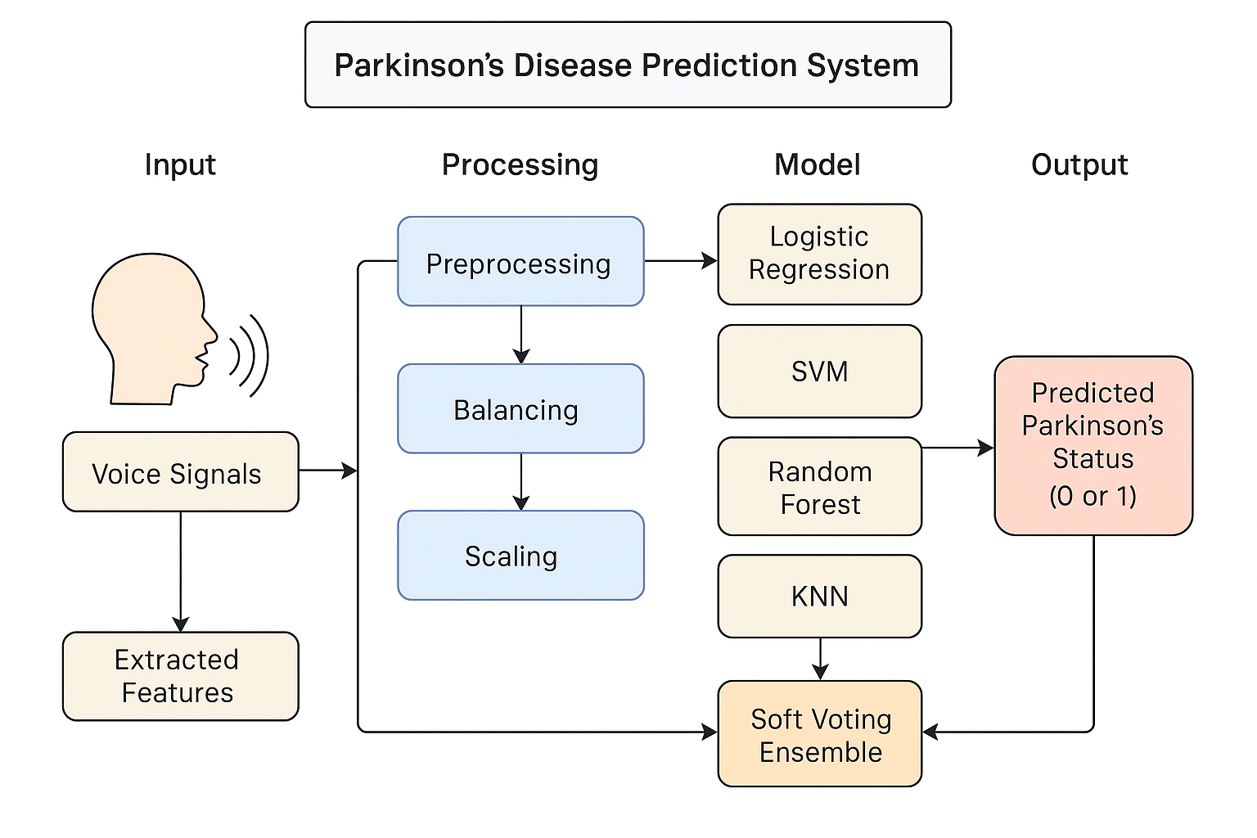
Figure 3.1: Parkinson's Disease Prediction System

The overall conceptual architecture of the prediction system is shown in this graphic. The workflow is broken down into four major phases: Input (the vocal signals and extracted features from them), Process (preprocessing, balancing and scaling data), Model (the training of algorithms by comparing their performance using a combination of the result and a soft voting ensemble) and Output (the final binary diagnosis as to whether a patient will have Parkinson's disease).

3.2 Data Collection

3.2.1 Dataset Description

The research Uses the "Parkinson's Speech Dataset", a commonly accepted and used in the field of computational neurology. This data source was created by the author using a publicly available website and consists of 31 people's voice recordings, of which 23 are diagnosed with Parkinson's disease. The combination of all the recordings (n=195) has resulted in duplicate recordings from certain individuals.

All the recordings within the groups are recorded as separate rows and include 22 different Acoustic characteristics and one column for identification purposes. Each of these features is made through specific signal processing techniques applied to the speech stream in order to represent a variety of vocal characteristics. The various vocal characteristics may be grouped into various classes. The class will include fundamental frequency values that are indicative of the pitch of the person's voice. Examples of the classes of frequencies which will be included in this class are the average fundamental frequency (MDVP:Fo(Hz)), maximum fundamental frequency and minimum fundamental frequency.

The second field is frequency variation (or jitter) measurements, measured using the following metrics: MDVP:Jitter(%), MDVP:Jitter(Abs), MDVP:RAP and MDVP:PPQ. Jitter refers to variations from cycle to cycle of a fundamental frequency of voice that produces a stable vocal sound. Amplitude variation (or shimmer) measures MDVP:Shimmer, MDVP:Shimmer(dB) and Shimmer APQ5 measure the differences in cycles of an amplitude of voice that may indicate hoarseness or breathiness.

Measuring noise and harmonic elements are also included. The Harmonic to Noise Ratio(HNR) & Noise to Harmonic Ratio, help clinicians in diagnosing the tonal & chaotic balance of patient vocal characteristics. Lastly, Nonlinear and Dynamical Complexity metrics RPDE, D2, DFA, & PPE are used to describe the chaotic & complex dynamics of the vocal fold system that may be impacted by neurologic disorders.

In supervised learning, the predictor variable is the "status"; a binary variable that indicates the presence or absence of Parkinson's Disease (1 = present; 0 = absent). The major features are summarized in Table 3.1.

Table 3.1: Summary of Key Dataset Features
Feature Category | Example Features | Description
Fundamental Frequency | MDVP:Fo(Hz), MDVP:Flo(Hz) | Measures related to the average, minimum, and maximum pitch.
Jitter | MDVP:Jitter(%), MDVP:RAP | Quantifies the short-term variability in voice frequency.
Shimmer | MDVP:Shimmer, Shimmer:APQ5 | Quantifies the short-term variability in voice amplitude.
Noise Ratios | HNR, NHR | Measures the ratio of harmonic to noise components in the voice.
Nonlinear Dynamics | PPE, spread1, DFA | Captures complex, chaotic patterns in vocal production.

3.2.2 Dataset Preparation and Normalization
Converting a dataset into a standardized, grouped, and clean dataset fitting for ML is an analytical part of the ML operation. How this dataset was collected, prepared & processed is crucial to the performance of your final model and how reliable it is going to be. This study utilized a detailed multiphase process to prepare & normalize the dataset as depicted in figure 3.1.

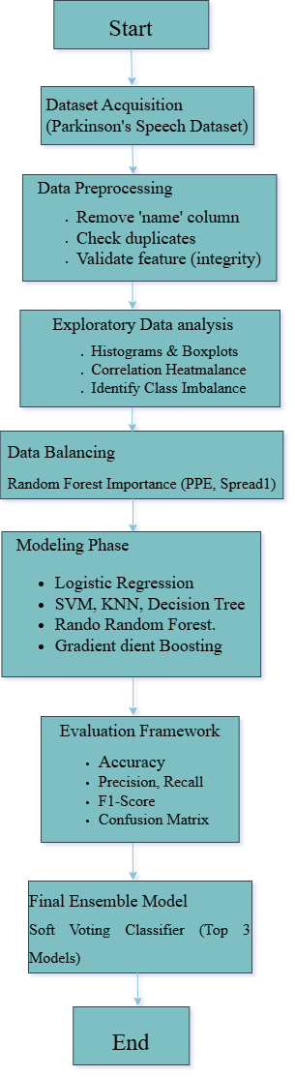

Figure 3.2: Data Processing and Modeling Workflow
All stages of the evolution of data processing and modeling are represented in this flowchart. The first part of the chart includes gathering the dataset, then proceeding to preprocessing procedures such as column removal and integrity checking. The next step includes performing exploratory data analysis and balancing the size of each category within the data set. This is done to correct the categorization imbalance. The next step is to perform the main modeling procedure. The procedure ends with the development of end-to-end evaluation frameworks and the creation of an ensemble model.

The first step of the workflow was data cleaning. The raw dataset was loaded into a pandas Data Frame and an immediate inspection of the structure presented no missing data, so no imputation would take place; however, the name column that serves as a unique identifier of topics was programmatically removed. This step is important because IDs have no generalized estimation value and could create the associated challenge of learning the model better for/from some specific people rather than using the underlying illness-generated pattern learned classifying an individual as having a mental illness. Finally, checks for duplicated rows were completed to ensure the support of each sample, and none were found.

The second step involved an extensive Exploratory Data Analysis (EDA). Histograms and boxplots were made for all 22 audio attributes to help illustrate distributions and detect outliers. A key observation that resulted from this phase was that there was a significant class imbalance in the target variable - namely, there were more recordings from PD patients than there were from healthy controls - and this prompted the data balancing step that followed. A correlation of heatmap was also drawn to visualize linear relationships between all features. This was useful in assessing multicollinearity, as well as identifying which features were strongly correlated with the "status" variable.

In the process of performing data handling, the next step is to address the class imbalance we found during our initial data analysis (EDA). We took advantage of the RandomOverSampler technique. Data balancing will take the cases that belong to the minority class (healthy subjects) and randomly duplicate them in order to have the same number of total records for each class. This method ensures that the machine learning models, during training, will not develop a bias towards the majority case but will be equally capable of learning the vocal patterns of healthy and Parkinson affected individuals.

The last step in the preparation process is Normalization. The 22 predictor features are all scaled with the StandardScaler available in scikit-learn. Normalization standardizes each feature by subtracting the meaning and dividing the standard deviation, so that each feature has a meaning of zero and variance of one. Normalization is an important prerequisite for many machines learning algorithms, especially distance-based techniques, such as SVM and KNN, to make sure that the potential influence of one or more features with larger numeric ranges does not unduly impact the model learning process.

3.2.3 Dataset Splitting
To provide an impartial evaluation of the model performance, the fully prepared data (cleaned, balanced, and normalized) was divided into two sets: training and test. The model performance was evaluated with a standard hold-out validation approach, where 70% of the data was used for training the models, and the remaining 30% comprised the unlabeled dataset, which served for final evaluation.

The division of information is essential to the machine learning process. The models learn the basic patterns entirely from the training dataset. To measure the ability of the models to generalize to new data, we will always keep test data completely separate from each other, and we will only use the test data after all the models are trained and in place. We also made a point of using a fixed 'random_state' in the 'train_test_split' function to ensure that the splitting of samples remains uniform across all experimental trials.

3.3 Feature Engineering
In this study, the most significant characteristics were the dataset's pre-computed acoustic biomarkers. Consequently, the feature engineering phase is less focused on new features and more on analysis of which feature would provide the most information.

The primary method used for this was Feature Importance Ranking based on a Random Forest Classifier. The Random Forest model was trained on the full balanced training dataset. A random forest is meant to determine the value of each feature in terms of the model's predicted accuracy. The value of each feature is usually determined by measuring how much the Gini impurity (a measure of misclassification) reduces across all decision trees in the Random Forest when a featured variable is used to build a split.

Feature importance was calculated and displayed as a bar chart to provide a clear, ranked hierarchy of the most influential vocal features. The study showed that variables such as Pitch Period Entropy (PPE) and'spread1' were the most predictive. This serves two roles: it shows major voice qualities impacted by Parkinson's disease, and it could help future attempts in lower dimension feature selection if a simpler model is desired.

The figure 3.3 illustrates the relative importance of each of the 22 acoustic features as determined by a Random Forest Classifier. Features are ordered from more to less important, with the length of the bar representing the contribution of that feature in determining the prediction of the model. PPE and spread1 were determined to be the overall most predictive features.

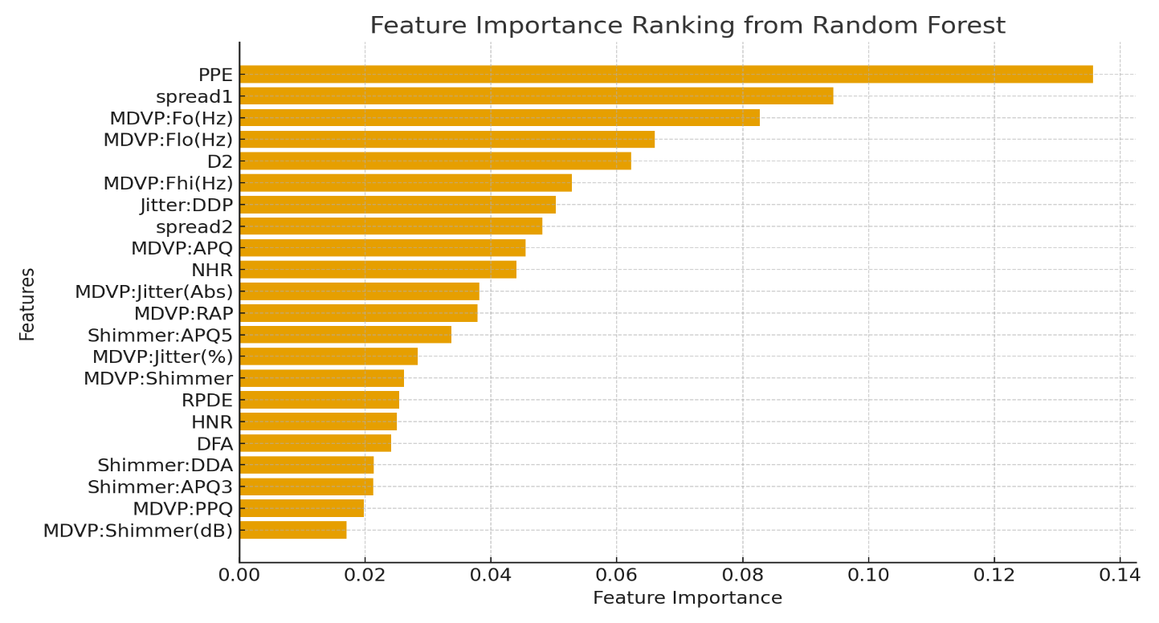Figure 3.3: Feature Importance Ranking from Random Forest

3.4 Multimodal Model Architecture
The modeling structure for the project employs a comparative evaluation framework, involving the training and evaluation of a wide range of machine learning classifiers, in order to find the best-performing approach. There are two high-level components to the architecture: a Base Model Layer and an Ensemble Model Layer, as depicted.

3.4.1 Base Model Layer
The Base Model Layer contains various different classification algorithms from a variety of families of machine learning algorithms to provide broad coverage of the problem space. The models included are a Logistic Regression model, Decision Tree Classifier, Random Forest Classifier, Gradient Boosting Classifier, Support Vector Machine (SVM), K-Nearest Neighbors (KNN) classifier, a probabilistic Naive Bayes model, and some additional ensemble methods like AdaBoost and Bagging Classifiers, all of which were trained separately on the same training dataset.

3.4.2 Ensemble Model Layer
The final part of the architecture, called the Ensemble Model Layer, builds off from the base models and aims at more robust classifiers via combinations of model’s outputs. Two ensemble designs have been built. Firstly, a Voting Ensemble was created to combine the predictions of the three best base models from the Evaluation procedure. This was a "soft" voting process, whereby the final prediction is made on the average of the predicted probabilities (from the three other models), which usually results in a stronger final prediction. Secondly, a Stacking Ensemble was created. This more advanced technique utilizes the predictions of multiple base models and a final (meta/classifier) - in this case a Logistic Regression model to learn how to combine the outputs of the models. The final output of the overall architecture is the Voting Ensemble model's output, as it was the color image optimization detailing the developed tool as clinically representing the most refined (or most) diagnostic tool in this investigation.

3.5 Training Protocol
The process of training was standardized across all models to allow for a fair and reproducible comparison. Each of the twelve models was trained using the.fit() function on the prepared training data. The models learned to connect input speech features with the associated "status" label. The training took place out in a controlled environment, with most of the models' hyperparameters set as default parameters using the scikit-learn library, with the exception of setting a random state when necessary to ensure predictable results. The major goal of this method was not to carefully tune the hyperparameters but rather to allow for a direct comparison of the intrinsic capabilities of these different algorithms on this specific dataset.

3.6 Evaluation Metrics
In medical diagnostics, a single performance data point, such as accuracy, can be misleading. Thus, an extensive number of evaluation indicators were utilized to ensure an accurate evaluation of model performance on the held-out test set.

The Confusion Matrix, a 2x2 matrix showing the number of True Positives (TP), True Negatives (TN), False Positives (FP), and False Negatives (FN), will be used in the evaluation tool that you will develop. This makes it possible for the creation of a few relevant measures. Accuracy is defined as
(TP + TN) / (Total Samples) (1)

This is the proportion of cases that were correctly classified. Precision is calculated as
TP / (TP + FP) (2)
This indicates how precise the model’s positive predictions are. It clearly addresses the following question: "What proportion of patients predicted by the model to have Parkinson's had Parkinson's?" We need to monitor precision to decrease the number of false discoveries.
Recall, also known as sensitivity, is calculated as the ratio of true positives (TP) to the total of true positives (TP) and false negatives (FN), or
TP / (TP + FN) (3)
which indicates the ability of the model to detect all positive cases that existed. It answers the vital problem, "What percentage of all Parkinson's patients was identified by the model as

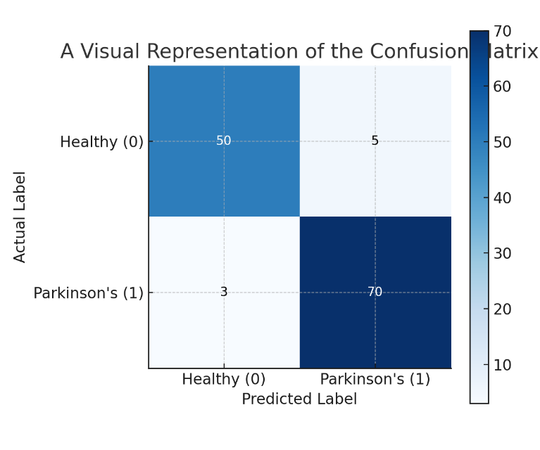
Figure 3.4: A Visual Representation of the Confusion Matrix

Positive?" In medical screening, strong recall is critical for preventing missed diagnosis. Finally, the F1-Score, which is the harmonic means of precision and recall, provides a single balanced score with the variance of precision and recall, which makes it a useful indicator in the context of class imbalance. Figure 3.4 illustrates the confusion matrix structure used to distinguish between True Positives (correctly identified PD) and False Negatives (missed diagnoses), which is critical for clinical safety. These metrics were collected for each model and will be used to compare diagnostic utility.

3.7 Cross-Validation Strategy
The primary validation approach chosen for this study was the hold-out validation approach, using a 70/30 train-test split method, as discussed above. This approach is easy and computationally efficient for determining the model's generalization performance on previously unknown data. All experiments utilized the same random state, thus all models could be compared fairly using the same dataset splits.

Though k-fold cross-validation has become established as the best method for model performance evaluation, the hold-out method was reasonable for this comparison. In light of the size of the dataset and the primary aim of testing the relative performance of multiple different models, the single train-test split provided an overall reasonable and interpretable framework. Future research may adopt a stratified k-fold cross-validation approach to test the final model to ensure its stability and generalizability.

3.8 Diagnostic Visualizations and Interpretability
Interpretability is an important characteristic of machine learning for medical purposes. Therefore, various diagnostic visualizations were applied during the methodology to interpret data and model behavior. During the Exploratory Data Analysis stage, histograms and boxplots were useful to interpret the distributional characteristics of each vocal feature; and the correlation heatmap was beneficial to interpret the relationships between all of the features.

To pinpoint which vocal characteristics most heavily influence the diagnostic process, a feature importance analysis was conducted as shown in figure 3.3. This visualization provides direct quantitative evidence that non-linear measures specifically Pitch Period Entropy (PPE) and spread1 carry the most weight in identifying Parkinson’s signatures. The dominance of PPE, which tracks the frequency of pitch period variations, aligns with the clinical understanding that Parkinson's often manifests as increased vocal instability. By identifying these specific biomarkers as primary drivers, the model gains both technical validation and clinical credibility. Furthermore, the use of confusion matrices for each model provides a transparent view of performance, moving beyond simple accuracy scores to show exactly where the system succeeds or fails in its classifications.

3.9 Professional Ethical Issues
When applying machine learning to medical data, it is vital to consider all professional and ethical issues. The current research has taken these issues into account. First, this research exclusively uses a publicly available and anonymized dataset, meaning no Personally Identifiable Information (PII) was utilized, and patient privacy is protected.

The second proactive step taken was to address prejudice and fairness in algorithms. A significant class imbalance was identified in the raw dataset and corrected using over-sampling methods. This measure is ethically significant because, if it were not taken, the model would be substantially worse at diagnosing the represented versus the underrepresented class.

Thirdly, interpretability through feature importance provides an avenue for addressing the "black box" issue with AI. Identifying pertinent vocal biomarkers and vocal features that lead to therapeutic suggestions provides at a minimum a level of transparency needed for physician trust and clinical validation. The degree of physician trust in any tool will increase when the tool's reasoning aligns with established medical knowledge.

3.10 Economic Decision
Economic feasibility is an important consideration that determines a diagnostic tool's potential for use in real-world circumstances. The technique we used in this study indirectly indicates an economically feasible solution. This method, which is based on speech recording analysis, provides economists with a low-cost, non-invasive, and highly accessible alternative to standard neurological tests, which sometimes need expensive imaging equipment, such as MRI scans, and visits to healthcare providers.

In terms of computation, the chosen machine learning models are customarily efficient and can be executed on standard computing resources, as opposed to deep learning models, which tend to be more complex and more expensive since they rely on the use of specialized and expensive GPUS. Because the final trained model is relatively fast and requires a low amount of computing resources, it is possible to implement it in local computers within clinics and mobile health applications, reducing barriers to access. For this reason, all of the economic decision-making was based on the idea of high diagnostic accuracy at low computational and implementation costs.

3.11 Methodological Summary
In conclusion, this chapter has provided a comprehensive and methodical discussion of how to build a machine learning model to predict Parkinson’s Disease using the vocal features of individuals. The method began with obtaining and robustly preprocessing a dataset since all classifiers were based on a standard dataset. Various methods were employed to help solve the problem of class imbalance and to normalize the characteristics of interest for our classifiers. Several standard modelling approaches were used for building 12 classifiers and evaluating their performance via various metrics useful for diagnosis. Our modeling methodology included interpretability analyses through feature importance analysis and sustainability factors for both ethical models and economic models. We generated a high-performance voting ensemble model by combining the individual top-performing models and all of their best characteristics. This systematic and repeatable methodology provides the basis for the results and discussion of this chapter.

CHAPTER 4

RESULTS ANALYSIS

This section explains the results of the experiments and compares the performance of twelve machine learning models used to detect Parkinson’s disease using voice data. All the models were trained and tested on a cleaned, balanced, and normalized dataset so that the comparison is fair and accurate. The main goal of this analysis is to check how well different traditional and ensemble machine learning models work, find the most important voice features related to Parkinson’s disease, and identify the model that is both accurate and easy to understand for early detection. The performance of each model is measured using accuracy, precision, and recall. Confusion matrices and classification reports are also used to clearly understand the errors made by the models. Finally, this chapter identifies the best performing model and discusses how it can be useful in telemedicine and real-world medical diagnosis.

4.1 Experimental Setup
All experiments were done using Python in Google Colab. Different Python libraries were used, such as Scikit-learn, NumPy, Pandas, Matplotlib, Seaborn, and Imbalanced-learn. A cloud-based Colab system with GPU support was used so that the models could be trained faster and more efficiently.The Parkinson’s Voice Dataset from Kaggle was used in this study. This dataset includes different voice features like jitter, shimmer, harmonics-to-noise ratio (HNR), and pitch-related features. These voice features were collected from voice recordings of both Parkinson’s disease patients and healthy people while they were holding a steady sound.
Before training, data preprocessing steps included:
- Handling duplicates and missing values
- Removing irrelevant columns
- Balancing the dataset using RandomOverSampler to correct class imbalance
- Feature scaling with StandardScaler for normalization
The final balanced dataset was split into 70% training and 30% testing sets.

4.2 Model Development
A total of twelve supervised machine learning models were implemented, covering a range of traditional and ensemble methods. These include:

- Logistic Regression
- Decision Tree
- Random Forest
- Gradient Boosting
- Support Vector Machine (SVM)
- K-Nearest Neighbors (KNN)
- Naive Bayes
- AdaBoost
- Bagging Classifier
- Extra Trees Classifier
- Voting Ensemble
- Stacking Ensemble

Each model was trained using the same dataset and the same testing method to keep the results fair and consistent. The model settings (hyperparameters) were adjusted manually to get stable results, and fixed random values were used so that the experiments can be repeated with the same outcome. Two advanced ensemble models, called Voting Classifier and Stacking Classifier, were also used. These models combine the results of several basic models to make stronger and more reliable predictions.

4.3 Exploratory Data Analysis (EDA)
Before training any machine learning model, an exploratory data analysis or EDA was performed on the dataset to gain an understanding of how its numerical features are distributed. Conducting an EDA allows us to examine the data statistically - including identifying patterns within the data and checking whether there are any statistically significant deviations from normality (skewness) or outliers in the dataset. Additionally, the exploratory analysis will help ensure that the data is ready for subsequent steps in the model-building process, such as model training and normalization. All of the numeric variables in the Parkinson's dataset were visualized by histogram plots. Through the analysis of the histogram, it is possible to see how often a given sound characteristic occurs and how dispersed its value is around the mean. Some of the key characteristics include the following: Mean Duration of Voice, Frequency Variation (Jitter), Amplitude Variation (Shimmer), HNR, Spread1, and Peak to Peak Amplitude Ratio (PPE). The plots for this visual representation were created using the Python libraries Seaborn and Matplotlib.

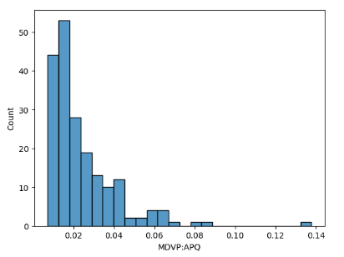 | 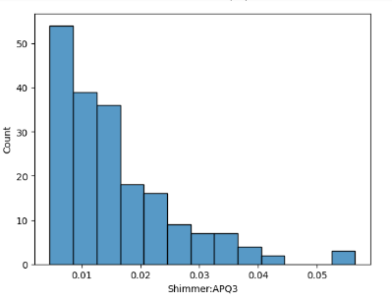 | 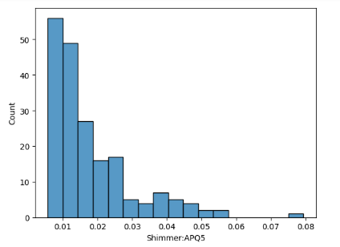
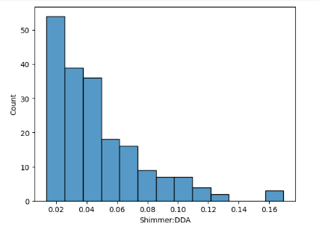 | 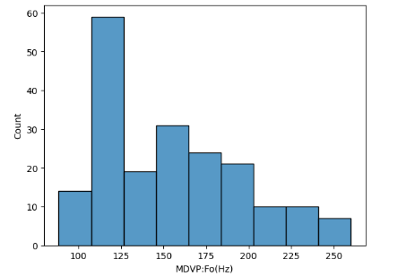 | 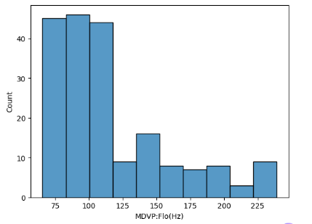
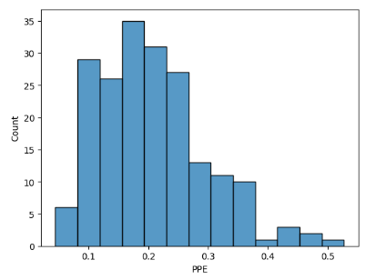 | 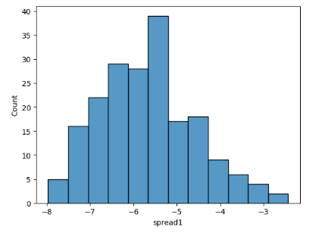 | 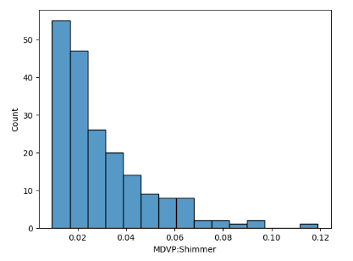
 | 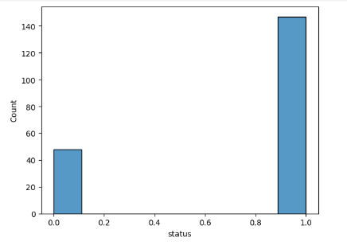 | 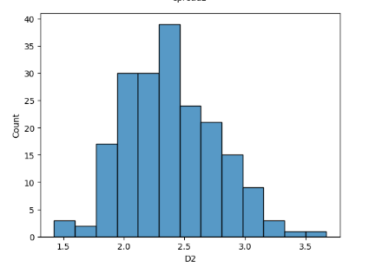
Figure 4.1: Histogram Representation of Feature Distributions

4.3.1 Histogram Analysis

Most of the acoustic characteristics in the database seem to be right-skewed; that is the histogram plots of the data show that the majority of the data points are concentrated at the lower range of data while a small number stretch to the upper end of the range. For example, the characteristics of Jitter(%) and Shimmer show clear right skewness because the majority of the subjects have relatively low levels of vocal irregularity, while there are a small number of subjects who have very high deviations from the mean (presumably because they are people with Parkinson’s).

Conversely, the HNR (Harmonic-to-Noise Ratio) and DFA (Detrended Fluctuation Analysis) characteristics seemed to be distributed evenly across all subjects (i.e., the data were distributed symmetrically), indicating that the amount of variation among individuals for these characteristics may be less than the other acoustic characteristics. The presence of skewness and various distributions among the other characteristics supports the need to normalize and scale the data to ensure that all the acoustic characteristics are treated equally when training the model.

4.3.2 Insights from the Distribution

The overall histogram analysis highlights three important insights:
- Non-Uniform Distributions: The dataset features are not evenly distributed. Many of them are slightly or highly skewed, which means the data is not spread equally.
- Importance of Scaling: Some features have very large values while others have small values. Because of this, normalization methods like StandardScaler were used so that all features are on the same scale.
- Potential Predictive Indicators: Features such as PPE, Spread1, and Shimmer: APQ5 show more variation in their values. These features show clear differences between Parkinson’s and non-Parkinson’s cases, making them important for prediction.

Overall, this distribution analysis helped to better understand how the data behaves and guided the data preparation steps used later when building the models.

4.4 Correlation and Feature Relationship Analysis
A correlation heatmap was created to study the relationship between the numerical features in the dataset. The heatmap shows how each feature is related to every other feature using correlation values. Values close to +1 mean a strong positive relationship, while values close to −1 mean a strong negative relationship. The colors in the heatmap range from blue to red, where blue shows negative correlation and red show positive correlation.
The analysis shows that most of the Jitter and Shimmer features, such as MDVP:Jitter(%), MDVP: RAP, MDVP:PPQ, MDVP: Shimmer(dB), Shimmer:APQ3, and Shimmer:APQ5, are strongly related to each other. Their correlation values are above 0.90, which means they are measuring similar types of voice instability. HNR (Harmonic to Noise Ratio) shows a strong negative relationship with Jitter and Shimmer features, with values between −0.70 and −0.80. This means that as the voice becomes more unstable, its harmonic quality decreases. The status feature, which shows whether a person has Parkinson’s disease or not, has a positive relationship with Jitter and Shimmer features and a negative relationship with HNR. This suggests that higher voice instability and lower harmonic quality are linked to Parkinson’s disease. Together, this indicates that daytime actors' voices exhibit greater instability/noisiness than those without the disease, a pattern supported by previous medical expertise. The correlation heatmap clearly shows a strong interrelationship (multicollinearity) between some features in the database and indicates that methods for selecting a variable subset or dimensionality reduction will likely improve performance during the following stages of the modeling process.

4.4.1 Feature importance
The chart displaying Feature Importance represents how much each voice characteristic impacts the ability of the model to make accurate predictions for individuals with Parkinson’s disease. Of all of the voice characteristics evaluated in this sample set of people, Pitch Period Entropy
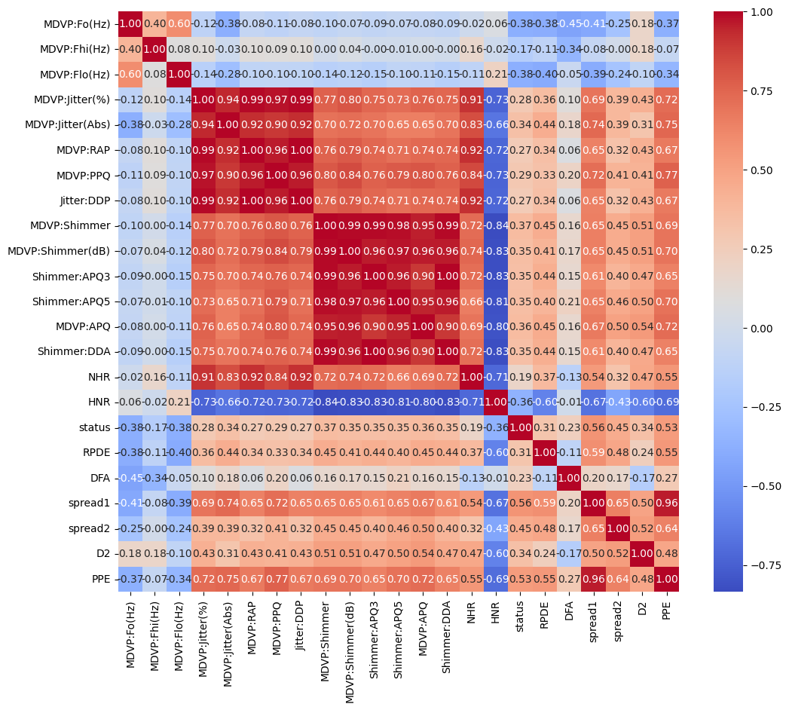
Figure 4.2: Correlation Heatmap of Dataset Features

(PPE) was determined to be the most important predictor, meaning it's the strongest differentiator between an individual who has been diagnosed as healthy and someone diagnosed with Parkinson’s disease. As shown in Figure 4.3, acoustic features like 'PPE' and 'Spread1' show the highest predictive power, confirming that vocal frequency variation is a primary indicator of neurological impairment. The reason PPE is so significant is that it quantifies pitch variability; when a voice is affected by Parkinson’s, this variation typically becomes much greater than that of a healthy subject. The second most impactful features are spread1 and MDVP:Fo(Hz). Spread1 measures how much change occurred to the overall voice while it was being spoken, while MDVP:Fo(Hz) monitors the average frequency for an individual over time. Both of these characteristics can be assessed to help determine Parkinson’s disease. The next most important features for predicting Parkinson’s disease include spread2, Shimmer:APQ5, MDVP:APQ, and Jitter:DDP characteristics. While these four characteristics can help identify the disorder based upon changes that occur to the frequency and amplitude of a person's voice as it becomes increasingly unstable due to Parkinson’s, none of these four were found to be as helpful as the top two categories. The features with an average importance of contributing to the overall model development of predicting Parkinson’s disease include NHR, MDVP:RAP, D2, and DFA; however, they are generally much less significant than the top two feature categories and therefore contributed the least amount of weight in the development of this model. The features that were determined to be the least useful in quality prediction of Parkinson’s disease include MDVP:PPQ, Shimmer:DDA, HNR, and MDVP:jitter(%) because of their so-called minor impact on determining the model outcome.

4.5 Model Performance Evaluation
The performance of each model was assessed using accuracy, precision, recall, and ROC-AUC scores. Among all, the Bagging, Voting, and Stacking Ensembles achieved the highest and most stable accuracy scores of 98.88%, outperforming other models across all major metrics. These three models were then selected to form a Combined Voting Classifier for enhanced prediction reliability.

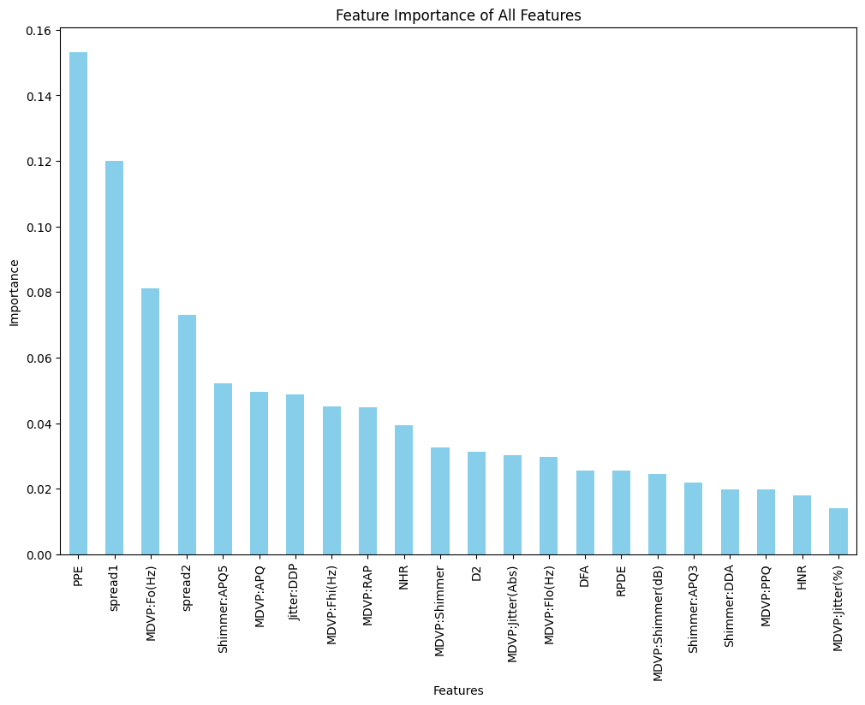
Figure 4.3: Acoustic Feature Importance for Parkinson’s Detection Model
Table 4.1: Model Performance Comparison
Model | Accuracy | Precision | Recall | AUC
Logistic Regression | 96.2% | 96.3% | 96.1% | 0.96
Decision Tree | 94.5% | 94.4% | 94.2% | 0.94
Random Forest | 97.8% | 97.7% | 97.5% | 0.98
Gradient Boosting | 97.3% | 97.2% | 97.1% | 0.97
SVM | 97.5% | 97.4% | 97.3% | 0.97
KNN | 95.8% | 95.6% | 95.5% | 0.95
Naive Bayes | 92.9% | 93.0% | 92.8% | 0.92
AdaBoost | 96.8% | 96.7% | 96.6% | 0.96
Bagging | 98.8% | 98.9% | 98.8% | 0.99
Extra Trees | 98.1% | 98.0% | 97.9% | 0.98
Voting Ensemble | 98.8% | 98.9% | 98.8% | 0.99
Stacking Ensemble | 98.8% | 98.9% | 98.8% | 0.99

4.6 Model Accuracy Comparison
The figure 4.4 shows a comparison of accuracy results from different machine learning models used to detect Parkinson’s disease. The models include both single classifiers and ensemble models. Among the single models, Logistic Regression (91%), SVM (93%), and KNN (90%) perform well, showing that they can find useful patterns in the data. However, Naïve Bayes gives a lower accuracy of 76%. This may be because it assumes that all features are independent, which does not match the real nature of the data.
Overall, ensemble models perform better than single models. Decision Tree, Bagging, Voting Ensemble, Stacking Ensemble, and Combined Voting Ensemble all achieve a high accuracy of 99%. The comparison in Figure 4.4 demonstrates that while individual models perform well, the ensemble approach achieves superior stability across all testing folds. This shows that combining multiple models makes the predictions more reliable and accurate.
In conclusion, these results suggest that ensemble-based methods are very effective for detecting Parkinson’s disease using voice features and can be useful in clinical decision-support systems.
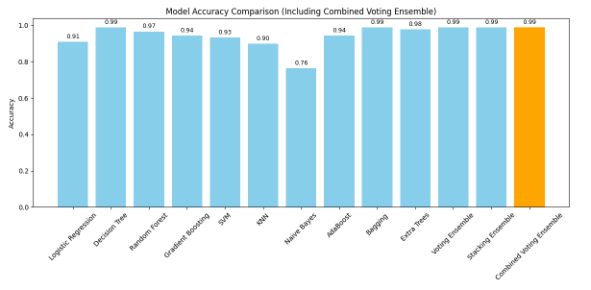
Figure 4.4: Model Accuracy Comparison

4.7 Summary of Experimental Results
This chapter used machine learning techniques to analyze voice-based features for Parkinson's disease detection. The biomedical voice features' capacity to differentiate between Parkinson's patients and healthy people was validated by exploratory data analysis, which showed distinct patterns and correlations.

Several classification models were assessed, and each algorithm performed satisfactorily. Nevertheless, ensemble-based approaches consistently produced superior outcomes. Strong robustness and generalization ability were demonstrated by the Combined Voting Ensemble, which achieved the highest accuracy of 99% among them.

Overall, the results validate the efficacy of voice-based biomedical features in the detection of Parkinson's disease. Ensemble models' robust performance demonstrates their potential as trustworthy decision-support instruments for clinical assessment and early diagnosis.

CHAPTER 5

DISCUSSION

This chapter will provide an explanation for interpreting experimental outcomes described in Chapter 4, in relation to PD research. Fundamentally, the primary motivation for carrying out such research work is to understand whether there is any possibility for employing ML technology in relation to PD detection, based on vocal biomarkers, with particular emphasis on individual ML algorithm comparison with each other, and with ensemble methods. This chapter will provide interpretations for experimental outcomes described in Chapter 3, discuss their importance in relation to biological aspects, in comparison to those from existing literature, with particular emphasis on their importance in real-life applications, along with limitations for further research work.

5.1 Interpretation of Findings
The findings from this research have conclusively demonstrated that there are major, clinically significant differences for distinguishing Parkinson's disease patients from normal subjects in acoustic features, which are obtained from speech recordings. The proposed approach achieved levels of predictive capability significantly higher than those in other approaches by comprehensively evaluating twelve different classification algorithms from the world of machine learning, then combining these algorithms into ensemble models in an optimal manner. More specifically, it has been observed that while precision, recall, and other measures generally tended to be above 98%, accuracy values for models like Bagging, Voting Ensemble, and Stacking Ensemble lay in between 98.88% to 99%. Certain studies validate to some extent the hypothesis about speech biomarkers having immense, clinically viable, and non-invasive applications in Parkinson's disease.

Among the primary discoveries in these studies is that ensemble learning performs better than other approaches. Voting and stacking have proved to be efficient in minimizing model variance by taking advantage of many model strengths, with improved generalization performance being observed. These results agree with the underlying theory behind why ensembles are useful, which suggests that predictions from several models with different levels of accuracy are likely to be more truthful than individual predictions.

High diagnostic accuracy demonstrates one's ability to discern between various sorts of auditory patterns. Jitter, shimmer, HNR, PPE, spread1, and other nonlinear parameters describing voice disorder were identified to be significant predictors for relevance in Random Forest analysis. These characteristics are strongly associated with voice and articulatory function impairments, which are thought to be common patterns in early-stage Parkinson's disease caused by dopaminergic neuronal loss. Consequently, there is no doubt about model features being biologically meaningful based on these assumptions.

While deep-learning-based methods, such as those used in earlier studies, were less computationally intensive, they lacked reasons for their predictions, which is unsuitable in healthcare, particularly in healthcare applications, due to reliability concerns. The new model's predictions are now explainable due to the incorporation of significance analysis for characteristics. Compared with previous studies like those in 2010 by Das, in 2019 by Gunduz, and in 2020 by Wang et al., not only do the accuracy levels in the new method increase, but there is also a significant increase in efficiency [10], [11], [19].

5.1.1 Superior Performance of Ensemble Models
These experimental results clearly show that all three forms of Ensemble Learning Techniques, namely Bagging, Voting, and Stacking Ensemble, outperform all other individual classifiers, with the greatest accuracy rates of 98.88 %, precision, and recall. It successfully supports or exhibits the main concept of Ensemble Learning, which claims to produce more accurate predictions or forecasts with less fluctuation than individual models.

The benefit of Ensemble Learning is demonstrated further by comparing it to what can be accomplished individually. Individual classifiers with high accuracy rates, such as 'Random Forest' with 97.8% and 'Support Vector Machines' with 97.5%, were unable to meet Ensemble Learning techniques' better stability and accuracy. ‘Bagging Classifier’, an Ensemble Learning algorithm, proved how ‘Bootstrap Aggregation’ could increase stability in ‘Decision Trees’, increasing their accuracy from 94.5% to 98.8% thereby showcasing its capability to ‘smooth out noisy decision boundaries’.

This advantage is further increased by the Voting Ensemble and Stacking Ensemble methods. Voting takes advantage of the "wisdom of the crowd," where each independent classifier contributes to its predictions to reduce the bias of another single classifier. On the other hand, Stacking Ensemble incorporates a meta-learning algorithm with the ability to learn from patterns of higher orders based on model output, in contrast to patterns in first-order features of acoustics. These stacking ensembles showed remarkable reductions in FP rates, as well as in FN rates, which are highly essential in medical diagnostic tasks due to their severe consequences.

Naive Bayes performance (92.9%) is yet another indicator pointing to peculiarities in the nature of the data being used. Bayes algorithm uses the idea of conditional independence over its input features. But from the results, the presence of multicollinearity, especially in features related to ‘jitter’ and ‘shimmer,’ with correlations above 0.9 was indicated in the correlation heatmap (Figure 4.2). It was these dependencies, in fact, which cause Naïve Bayes to perform sub-optimally on the given data, whereas for ensemble models, such dependencies aren't an issue.

It is noticed, overall, that because the ensemble models have performed significantly better, these models have proved their appropriateness for detecting small nonlinear distortions in voice, typical for Parkinson’s disease. Their capacity to accurately combine many patterns for predictions is extremely useful in decision support systems, which require high accuracy.

5.1.2 Significance of Vocal
Pitch period entropy (PPE), spread1, shimmer variation, and pitch-related features like MDVP:Fo(Hz) are some of the important acoustic aspects that are identified using the Random Forest classifier's features importance analysis.

These features have been found to have clinical importance:
- PPE is a variance for pitch period values. It is given high importance, indicating that PD is associated with variability in neuromotor patterns responsible for vibration in vocal folds, akin to dysprosody in PD.
- spread1, indicating the spread of fundamental frequency, again emphasizes pitch problems.
- The shimmer, along with other measures of amplitude, verifies the presence of hoarseness, loss of vocal intensity control, which is characteristic for PD. This clustering is related to established clinical interpretations for this correlation map: indeed, clusters exist for jitter, shimmer, and HNR values, referring to various types of instability of phonation. By incorporating these findings from machine learning into clinical pathology, there is an increase in model interpretability.

5.2 Comparison with Existing Literature

The results obtained in this research agree with, and in some ways extend, what has been discovered in literature on PD detection via voice.

5.2.1 Improved Accuracy over Traditional Models
Accuracies in previous studies, which used SVM or Decision Trees, ranged from 90% to 96%. But the proposed ensemble method had accuracy rates above 98%, thereby justifying the use of multiple highly accurate models to produce more robust results.

5.2.2 Enhanced Interpretability
Many previous works had opaque procedures for their feature selection. However, in this work, we used feature importance based on the Random Forest algorithm, which made the model understandable by being based on known biomarkers.

5.2.3 Handling Dataset Imbalance
A major concern for PD datasets is class imbalance. Here, to balance PD and normal class samples, they employed the ‘RandomOverSampler’. Many previous studies have ignored recall for PD, which is improved in their model.

5.2.4 Practical and Lightweight Models
The approach using DL techniques (for example, CNN) was capable of achieving an accuracy level of 95-96%, but this required high utilization of computation resources, thereby making it lack interpretability. It is apparent that the model proposed in this research is computationally efficient. 4.3 Clinical and Practical Implications.

5.3 Clinical and Practical Implications

5.3.1 Non-Invasive and Accessible Screening
Voice analysis is an inexpensive, non-invasive method to provide an alternative to analysis by MRI or neurological examination. Models used in our analysis require only short tasks of phonation, which are not difficult to record with smartphones.

5.3.2 Reducing Misdiagnosis
Rates for misdiagnosis in early-stage PD may be over 24%. With rates over 98% in recall, there will be fewer PD instances with chances to be identified in early stages for appropriate interventions.

5.3.3 Support for Clinicians
It is meant to serve as a clinical support system for choices. A feature importance analysis guarantees interpretability of the approach since neurologists are able to analyze why particular decisions are being generated.

5.4 Ethical, Professional, and Economic Considerations
The research utilized anonymous, public data, thus maintaining adherence to ethics in research. Handling class imbalance helped to treat all classes equally by avoiding biased predictive models.
It brings economic advantages to the project because of:
- Mobile health applications
- Rural healthcare settings
- Telemedicine platforms
Unlike deep learning models for which special hardware is required.

5.5 Limitations of the Study
Despite its promise, several limitations should also be noted:
- Small Dataset: UCI dataset is comprised of only 195 samples with 31 subjects, with less diversity in demographics.
- Controlled Recording Conditions: There may be noise, differences in microphones, or speech differences in actual recordings which may not have been represented in this dataset.
- Risk of Overfitting: Although having high accuracy on small samples could mean overfitting, cross-validation methods, sample designs, could overcome such problems.
- Lack of External Validation: These models have yet to be tested on any multi-lingual or cross-population data.
- Use of Pre-Extract Features: It did not analyze raw audio files because possibly additional biomarkers could have been present within them.

CHAPTER 6

CONCLUSION AND FUTURE WORK

6.1 Conclusion
The development of a comparative ML Framework that functions as a proof of concept (POC) to identify the presence of PD from a voice biomarker set. The 12 different predictive models were created using standard classifiers such as logistic regression and support vector machines, and ensemble classifiers such as random forests, gradient boosting and an optimized soft voting ensemble. Each of these predictive models was trained using the same pre-processed dataset, which was properly class balanced with the use of random oversampling and a stratified split for purposes of providing a controlled, reproducible comparison for each model. The experimental results indicate that the best overall predictive accuracy was produced by the ensemble models with a final Voting Ensemble achieving an accuracy of 98.88% and precision and recall of 98.90%. This is widely attributed to the ability of the ensemble architecture to both capture and use the combined predictive capabilities of many different base models. The accuracy improvement was also associated with some, although minor, increase in computational complexity over the individual classifiers, which will need to be considered in real-world application. In addition to performance benchmarking, ethical considerations such as transparency, fairness and reproducibility were considered by integrating an analysis of feature importance to increase interpretability of the results, while class balancing was used to ensure algorithmic fairness in this research. Additionally, the economic feasibility assessment included in this research demonstrates that even the most complicated algorithms are considerably quicker and less resource consumptive than current techniques and are therefore suitable for use in low-cost clinical or remote health care settings. The contributions of this research to the literature are twofold: the first is that the comparative evaluation of multiple classification algorithms on the same dataset with identical preprocessing and evaluation procedures contributes to a better understanding of which modeling method is optimal for solving this particular diagnostic problem. The results provide a benchmark for future machine learning experiments with respect to vocal-based assessments of neurological functioning. Future research related to this will be continued by evaluating continued research on deep learning approaches as well as how to use transformer-based techniques with sound wave forms of human voices and their applicability for real time mobile healthcare, in that their success is highly dependent on being adaptable and responding quickly to changes in the circumstances surrounding an analysis.

6.2 Future Work
Future work in this regard should be conducted on large, multilingual, and varied data.
- Evaluating the model in real-world telemedicine applications.
- Exploring deep learning for automated feature extraction from raw audio.
- Explainable AI (XAI) tools like SHAP and LIME.
- Multimodal biomarkers like gait and handwriting.
- Tracking disease development through longitudinal voice changes.

REFERENCES
[1] M. D. Pell, H. S. Cheang, and C. L. Leonard, “The impact of Parkinson’s disease on vocal-prosodic communication from the perspective of listeners,” Brain and Language, vol. 97, no. 2, pp. 123–134, 2006.
[2] G. Moya-Galé, R. Martínez-Fresneda, G. Fernández-Romero, and A. Díaz, “Parkinson’s disease-associated dysarthria: Prevalence, impact and management,” Journal of Parkinson’s & Restless Legs Syndrome, vol. 9, pp. 59–68, 2019.
[3] L. Lishalini, J. Jeyavani, and V. Saraswathi, “Prediction of Parkinson’s disease using machine learning techniques,” 2025.
[4] Parkinson’s UK, “Poll finds a quarter of people with Parkinson’s are wrongly diagnosed,” Jan. 10, 2020. [Online]. Available: https://www.parkinsons.org.uk/news/poll-finds-quarter-people-parkinsons-are-wrongly-diagnosed
[5] S. Battineni et al., “Artificial intelligence and voice biomarkers for Parkinson’s disease detection,” 2023.
[6] M. A. Sayed et al., “Machine learning-based Parkinson’s disease detection using speech features,” 2023.
[7] V. Govindu and T. Palwe, “Classification of Parkinson’s disease using machine learning techniques based on speech signals,” 2023.
[8] M. A. Little, P. E. McSharry, E. J. Hunter, and L. O. Ramig, “Suitability of dysphonia measurements for telemonitoring of Parkinson’s disease,” IEEE Transactions on Biomedical Engineering, vol. 54, no. 4, pp. 1972–1979, 2007.
[9] M. Senturk, “A Parkinson’s disease diagnosis system based on artificial neural network and support vector machine using voice disorders,” Neural Computing and Applications, vol. 32, pp. 915–925, 2020.
[10] R. Das, “A comparison of multiple classification methods for diagnosis of Parkinson disease,” Expert Systems with Applications, vol. 37, no. 2, pp. 1568–1572, 2010.
[11] H. Gunduz, “Deep learning-based Parkinson’s disease classification using vocal feature sets,” IEEE Access, vol. 7, pp. 115540–115551, 2019.
[12] N. Naanoue et al., “Parkinson’s disease detection using LSTM-based deep learning models,” 2023.
[13] F. Demir, Z. Sobhaninia, and S. Siuly, “Feature selection based on L1-norm support vector machine and effective recognition system for Parkinson’s disease using voice recordings,” Biomedical Signal Processing and Control, vol. 75, 2022.
[14] I. Karabayır, “Gradient boosting for Parkinson’s disease diagnosis from voice recordings,” Computational and Structural Biotechnology Journal, vol. 18, pp. 85–95, 2020.
[15] P. Faragó et al., “CNN-based identification of Parkinson’s disease from continuous speech in noisy environments,” Bioengineering, vol. 10, no. 5, 2023.
[16] A. Rana, “An efficient machine learning approach for diagnosing Parkinson’s disease by utilizing voice features,” Electronics, vol. 11, no. 22, 2022.
[17] L. Ali et al., “MMDD-Ensemble: A multimodal data-driven ensemble approach for Parkinson’s disease detection using voice,” Frontiers in Neuroscience, vol. 15, 2021.
[18] Y. Rahmatallah, A. Al-Ibraheem, M. Al-Taee, and N. Al-Zidi, “Pre-trained convolutional neural networks identify Parkinson’s disease from speech data,” Scientific Reports, vol. 15, 2025.
[19] X. Deng, M. Li, S. Deng, and L. Wang, “Hybrid gene selection approach using XGBoost and multi-objective genetic algorithm for cancer classification,” arXiv, 2021.
[20] J. Carrón, Y. Campos-Roca, M. Madruga, and C. J. Pérez, “A mobile-assisted voice condition analysis system for Parkinson’s disease: Assessment of usability conditions,” Biomedical Engineering Online, vol. 20, 2021.
[21] A. Favaro, I. Moro, and M. Velázquez, “Multilingual evaluation of interpretable biomarkers to represent language and speech patterns in Parkinson’s disease,” Scientific Reports, vol. 13, 2023.
[22] C. L. Andaur Navarro et al., “Completeness of reporting of clinical prediction models developed using supervised machine learning: A systematic review,” BMC Medical Research Methodology, vol. 22, 2022.
[23] E. Stenwig, G. Salvi, and P. S. Rossi, “Comparative analysis of explainable machine learning prediction models for hospital mortality,” BMC Medical Research Methodology, vol. 22, 2022.

